**MONISHA.DUSANAPUDI**

**Phase 3 Report: Data Modelling & Relationships**

**Non-Profit Donation & Volunteer Management**

**Objective:** The primary goal of Phase 3 was to design and implement a custom data model to support the Volunteer Management requirements of the application. This involved creating custom objects, defining relevant fields, and establishing the correct relationships to accurately track volunteers and their participation in events, while integrating seamlessly with the existing NPSP data structure.

**Standard & Custom Objects**

* The data model was built using a combination of standard and custom objects.
  + **Standard Objects (from NPSP):** The Contact object is utilized to store information for all individuals, serving as the primary record for both Donors and Volunteers. The Opportunity object is used for all Donation records, as configured by NPSP.
  + **Custom Objects:** To meet the specific needs of volunteer management, two new custom objects were created:
    1. Event: This object was created to serve as a central repository for all information related to a specific volunteer event, such as a charity gala or a community outreach day.
    2. Volunteer Hours: This object was created to serve as a junction between Volunteers and Events.

**Fields**

* The Event object was enhanced with four custom fields to capture essential information:
  + Event Date (Date): To store the date on which the event will take place.
  + Location (Text Area): To store the physical address or venue of the event.
  + Description (Long Text Area): To provide detailed information about the event's purpose and activities.
  + Max Volunteers Needed (Number): To track the capacity for volunteer sign-ups.

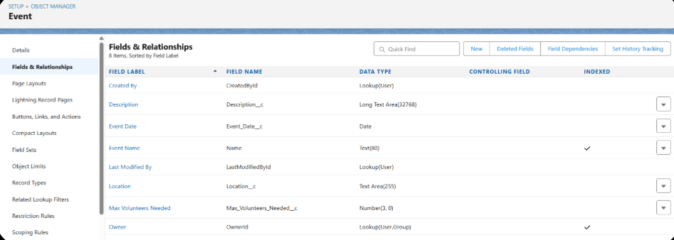

**Relationships: Master-Detail & Junction Objects**

* A many-to-many relationship was identified between Volunteers (Contacts) and Events, as a single volunteer can attend many events, and a single event will have many volunteers. To resolve this, the Volunteer Hours object was created as a **Junction Object**. Two **Master-Detail Relationships** were created on this junction object:
  1. A master-detail relationship to the Contact object (renamed "Volunteer").
  2. A master-detail relationship to the Event object.

**Schema Builder**

* The Salesforce Schema Builder was used to visualize the newly created data model.

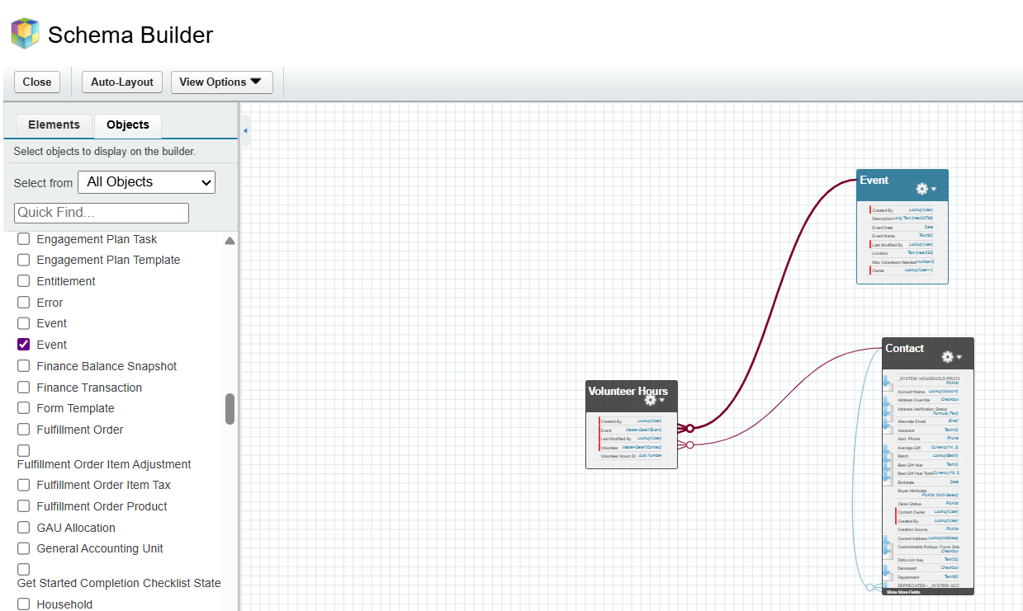

**Page Layouts & Compact Layouts**

* As each new custom field was created for the Event object, it was automatically added to the default page layout. Similarly, the master-detail relationship fields created new "Related Lists" on the Contact and Event page layouts.

**TESTING THIS PHASE**

To ensure the data model was functioning as designed, a comprehensive end-to-end test was performed.

* **Test Scenario:** A volunteer named "Susan Volunteer" needs to be signed up for the "Annual Charity Gala" event.
* **Test Execution Steps:**
  1. **Data Creation:** A new Contact record was created for "Susan Volunteer." A new Event record was created for the "Annual Charity Gala."
  2. **Relationship Creation:** Navigating to the Event record for the Gala, a new Volunteer Hours record was created from its "Related" tab, linking the Gala to the "Susan Volunteer" Contact record.
* **Test Results & Verification:**
  1. **Result 1:** When viewing the "Annual Charity Gala" Event record, the Volunteer Hours related list correctly displayed **one entry**, showing that Susan Volunteer had signed up.
  2. **Result 2:** When viewing the "Susan Volunteer" Contact record, the Volunteer Hours related list also correctly displayed **one entry**, showing she was signed up for the Annual Charity Gala.

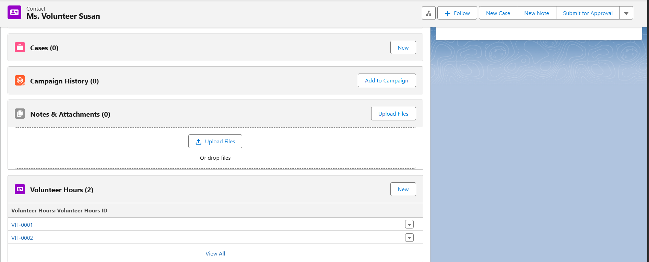

* **Conclusion:** The ability to see the correct relationship from both the parent Event record and the parent Contact record provides a **successful two-way verification**. It confirms that the junction object and the master-detail relationships are working perfectly, and the data model is robust and reliable.